# 2.9.1

From Financial Aid:

Based on a state financial aid audit, Subpart B must read as follows:

Probation: Subpart B. Probation

Students whose appeals are approved are placed on probation for one evaluation period under an approved academic plan. Students on probation are allowed to register and may receive financial aid if eligible. If, at the end of the next evaluation period, a student on financial aid probation status:

1. Has met the institution's cumulative grade point average and completion percentage standards, the student shall be returned to good standing.
2. Has not met the institution's cumulative grade point average and completion percentage standards but has met the conditions defined in the student's academic plan, the student shall retain financial aid eligibility as specified under the academic plan.
3. Has not met the institution's cumulative grade point average and completion percentage standards and has also not met the conditions specified in the student's academic plan, shall be suspended immediately.

Response: We’ve reverted the language to what the audit requires.

-I suggest removing “in writing” in this sentence being it’s simply submitted using the form. This “in writing” language is also under the Notification of Status and Appeal section of the procedure so maybe in that area it’s stated as “by email” or maybe that’s too picky and in writing is just fine.

“In writing” can be via email.

-The CSAO position doesn’t really exist anymore does it?

Thanks! We’ve updated language!

-The his/her could be more inclusive by using their perhaps.

Thanks! We’ve fixed this.

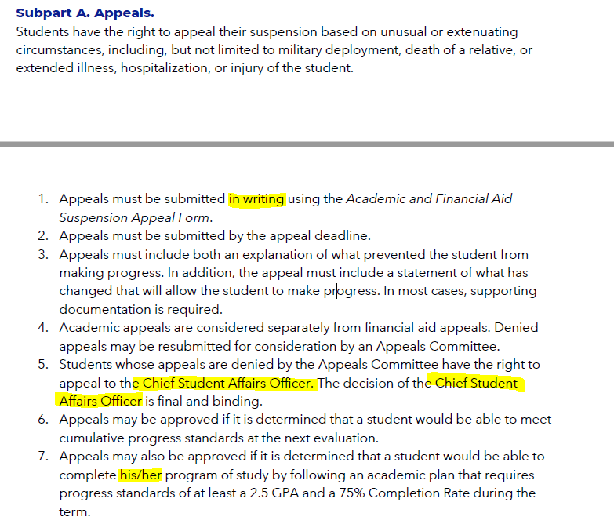

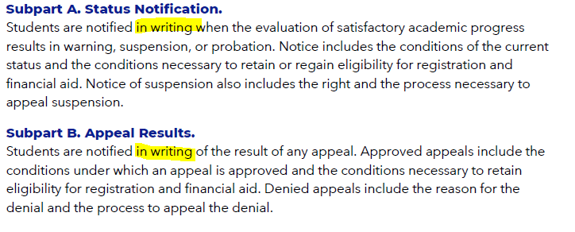

My apologies if this is a duplicate comment as I remember typing it earlier, but can’t find it in my email so not sure that it was ever sent.

The words **Probation** and **Academic Plan** do not conflict with each other as they are both terms recognized in regulation. They both serve a purpose and must be used appropriately.

**Probation** is the academic status of a student the term they return to the school after an approved appeal. That is the name of the hold that goes on the student’s record in ISRS and the message they see in eServices.

**Academic plan** is the course of action a student must follow to remain eligible for financial aid until their cumulative GPA and completion rates are meeting SAP standards and the student is in good academic standing.

Please don’t hesitate to reach out if you have any questions or concerns.

Thanks for this clarification!

# 3.6.1

Typos: Part 1, Subpart A (double “will”); Subpart B (“Falsifying of Withholding Information”), Part 3, “implement promote”

Thanks for catching these!

Part 3, #6: It's problematic to list this under a phrase that restricts faculty actions to repeated violations. I only submit a complaint when a student has blatantly plagiarized after completing (or choosing not to complete) several assigned readings, practice exercises, and quizzes that cover all aspects of plagiarism. Faculty shouldn't be limited to reporting ONLY when a student plagiarizes more than once. In that case, students can (and have) plagiarized multiple times across multiple classes without facing any consequences. This limitation is especially problematic given the increasing prevalence of AI.

Our goal here is to promote a growth mindset and learning opportunity, and we are concerned that filing a code of conduct can be perceived as punitive and interfere with the learning opportunity. We really want to encourage all of us to feel safe in situations that are potentially uncomfortable.

Part 3, reporting to appropriate Academic Dean and the Conduct officer: Is this new? Do we use separate forms/processes for notifying each? I've only notified the Conduct Officer unless there is a very specific reason to notify the dean. It seems excessive to notify deans of every infraction.

No, this is existing language. We clarified that this intended only when filing a code of conduct.

* Subpart A. Academic Integrity
  + “….students will: Turn in assignments they have completed through their own efforts”
* Update for AI? If student “effort” is prompting GPT4 for an answer, to compose/write, wireframe a website, etc., the student effort is for the prompt, not the AI results!
* Subpart C, 4 (technology):
  + AI not mentioned here; “unauthorized software” is mentioned only for installing/downloading, but not for “using;" AI is easily accessible from public-facing websites

We recognize that ai has a unique set of challenges. We want to ensure our policies can reflect our current as well as future needs as other tools develop. We reframed to try to get closer to the intent without specifically calling out AI.

I truly appreciate the reframing of the Code of Conduct Procedure. It has a much better overall tone of NHCC’s expectations.

Thank you!

# 3.21

From Records & Transfer:

Change fractions in Subpart E Semester vs. Quarter to decimals (.67 and 1.5).

Done!

# 3.21.1

Not sure what the “fix” in this paragraph means so probably can be removed:

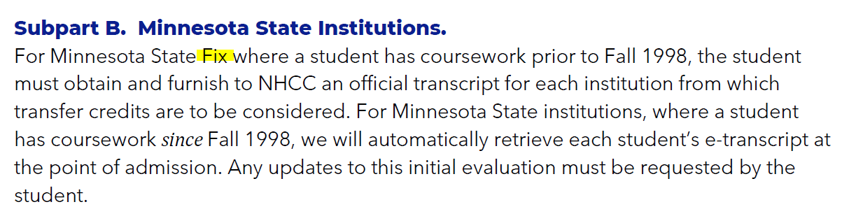

Since we don’t have a specific Transfer Advisor anymore, this can say just basically meet with an advisor in the Advising Center.

Then for Step 3, the next step is to appeal to the Provost (so Julio receives these now)

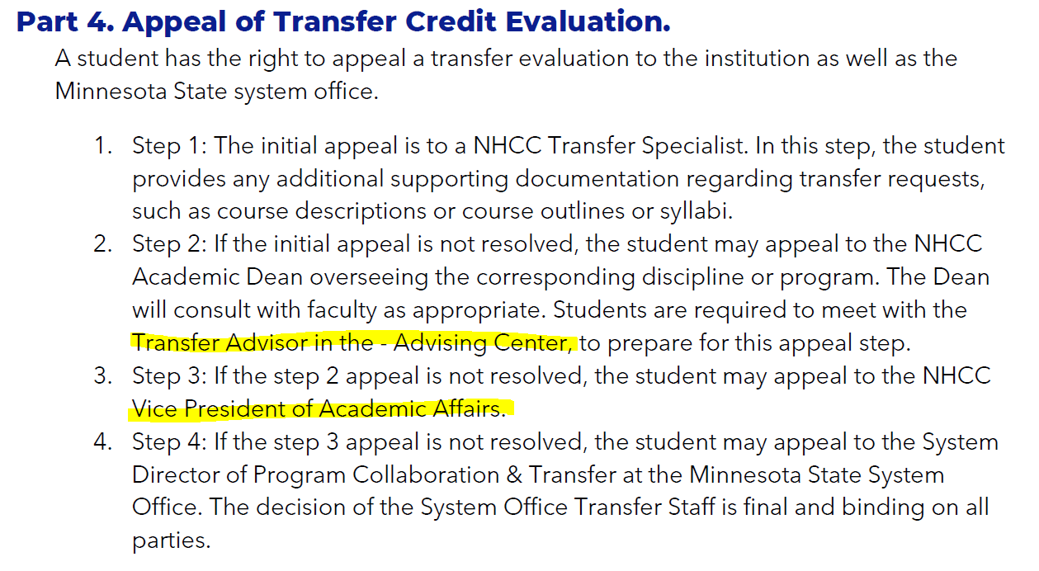

Thanks! Fixed!

From Records & Transfer:

Part 2 Subpart A #2, change “originating college” to Minnesota State Institution

We’ve chosen not to call this out due to our partnership with University of Minnesota

Subpart B: What is Fix?

We wondered too! Changed it to “institution”

Part 3: change from Minnesota State colleges to “institutions”; update references to “goal” to “goal area”

Thanks!

Part 4: #2, change Transfer Advisor to “an Academic Advisor”; #3, change VP of AA to Provost #4 change System Director to Senior Vice Chancellor for Academic and Student Affairs

Done, thanks!

* Part 2, Subpart C, Professional/Occupational Courses
  + categories: do “technical” or “service” categories include Graphic Design? I’m accustomed to GDES labeled as “CTE” for career & technical education

This refers to something that we don’t have an equivalent course for. If a student had something that looked like graphic design, we’d give them credit if it was 70% equivalent. But if they had floral design, it would come in as technical credit.

# 3.22 Course Outline and Course Syllabi (Normal review cycle)

From Access Services:

* One week of the first class does not give all students the space to know if the amount of course work will be too heavy.

We struggle with this. First, regardless of opinions, this is Board Policy. We see the need for students to understand what they’re signed up for. And many faculty create the syllabus with their students during that first week of class. We think a better approach is to have a culture shift that encourages students to reach out to potential faculty and faculty to respond to student needs.

* It should be one week prior to the start of the first day of classes. So students have time to review know if the course is right for them and course load is feasible with their schedule.

Faculty are not paid to work until the first duty day before classes. We cannot require faculty to do work when they are not paid.

* Allowing this time for our instructors does not benefit our students.

See comments above

# 3.37.1

A typo in 3.37.1

requirements.

### Subpart F. Minnesota Transfer Curriculum (MnTC) Audit.

NHCC shall make an MnTC audit available to all Minnesota State institutions and Univerity of Minnesota.

Thanks!

From Records and Transfer:

Part 3, Subpart B suggested language:

1. A single course can address no more than two Goal Areas; however, Goal Area 2 may be assigned as an additional Goal Area, if applicable.
2. Goal Area 2: Critical Thinking is incorporated throughout the curriculum. A student upon completion of the ~~degree or the~~ MnTC will have fulfilled this requirement for transfer. Completion of any degree at NHCC (AAS, AS, AFA, or AA) also fulfills the Critical Thinking requirement.

Thanks!

Part 3, Subpart 3 suggested language:

A selection of specific courses that apply to each MnTC Goal Area are published on the NHCC website under Academics, All Programs.

While this is currently accurate, we’re concerned about putting a road sign into the policy when there is ongoing updating of the website.

Part 4, Subpart F:

For system institutions, this is available via eTranscript. For the U of M, is this something we are required to be practicing?

We just need to make it available, we don’t have to provide it if it is not requested.

# 3.50.1

Regarding Incompletes. Do we really follow this procedure? Is there really a form that is filled out by faculty and signed by both the student and the faculty? I agree there should be, but is this actually followed? (I meet with a lot of students who have no idea they have an Incomplete, and have not filled out any kind of form)

Yes, there’s a form, we’ll try to do better getting this on everyone’s radar where to find the form. We want avoid situations where students don’t know they have incompletes.

From Records and Transfer:

Part 2 Subpart D:

Currently, no courses have the P/F grading schema.

This is true, and it is an option that exists.

Subpart E: Remove “Visitor or”

Done!

Right before part 3, change language about incomplete lapsing to “will be changed to”

Done!

Part 3: honors eligibility does not match what is on the website

The language in this policy is requested by Honors. Once the policy is approved, the website will be updated.

# 3.52

The first feedback in in reference to multiple sections. The policy as written seems to limit a maximum of two sections being combined. Current practice in Biology (based on feedback from the Biology UFT several years ago) allows us to combine up to 3 sections of certain courses (e.g. BIOL 1001). I suggest rewording the policy to allow this practice to continue.

Changed language, thanks!

The second feedback is in reference to the economic considerations section. I understand that a cost study conducted in the past arrived at the number 23. I would like for us to reconsider this given our current financial realities.

We’ve modified to reflect the last study that was done. We’re happy to reopen the policy when a new analysis is completed. Keep in mind that max class size is not the same as tally, which is what we tend to work more with.

# 4.9.1 Faculty Evaluation Procedure (Requested by MSCF leadership)

From Access Services:

* Why student feedback not mandatory, our students voices matter and should weigh highly in on instructor evaluations.

The faculty evaluation procedure is the only one on our campus that includes student feedback as an option. Not all student feedback is of the same quality, and so there is fear and concern about weighing student feedback too heavily. The other side is that deans collaborate in the process, and can insist on student feedback as appropriate.

* Reviewing all negative feedback should be required with Dean. Instructor and Dean can work together on what is appropriate to address and what isn’t.

We talked about this, and are concerned about using the term “negative,” we feel that this works against the growth mindset culture we are working to create. We do feel the spirit of this request is present in Part 4, Subpart B.

Why is the PDP listed under the Faculty Evaluation Process as an “option” under Part 3 Evaluation Methods if the PDP is required every year (it says annual in the option)?

This appears to be a lot more work for faculty members, especially the self-evaluation option, which seems very similar to the PDP.

The intent was to have the PDP serve as part of the evaluation, rather than creating more work, it’s supposed to alleviate work.

Typos: Subpart F. Supervisor Review “Every At the”; Subpart B. Meeting “activitesevaluation” and “supervisoryfaculty”

Thanks!

Part 6, Subpart A #5e: Does this imply all three must be completed every year? Since some roles, such as governance, require more of a time commitment than others, some activities count as service or vice versa, the college's needs and faculty's roles/schedules vary from year to year, and we want to encourage faculty to participate according to their individual talents, should this read "and/or" instead of "and"?

Did and/or, thanks!

Here's my attempt at introducing the 3-year cycle earlier:

## Part 3. Evaluation Methods.

Faculty will work collaboratively with their supervisor to design a 3-year evaluation cycle. Each year of the 3-year cycle should utilize a different evaluation method. Evaluation methods may include any of the following:

[no proposed changes to descriptions of Subparts A-C]

Part 3, Subpart D, 2:

Could we say: "...strategies the member will take to work towards ***or maintain*** parity of outcomes…"?

[no proposed changes to Subpart E]

Part 3, Subpart F:

Just delete the word "Every" at the beginning of that paragraph

[no proposed changes to Subparts G or H]

## Part 4. Evaluation Cycle.

Each year, supervisors and faculty will collaborate to document results(?) findings(?) outcomes(?) of the most recently completed evaluation method or to design a new 3-year evaluation cycle. All pertinent documentation related to faculty evaluation will be maintained in the supervisory file.

Part 4, Subpart B, first paragraph: I think you want to delete the word "evaluation" at the end of that first paragraph.

I just looked at the Faculty Evaluation doc, and it still feels weird to me that Part 3 talks about annual evaluation and then Part 4 talks about a 3-year cycle and that's the first time we see it. I understand that Part 4 is titled Evaluation Cycle, but it still feels like the 3-year issue should be brought up earlier. Could Evaluation Cycle be included in Part 2: Definitions? That would take care of it, I think.

In part 3, sentence 1, "annual evaluation each year" feels redundant, but there might be a reason for that wording. (like the meeting must happen each year and the **evaluation** is what's being described as annual)

Finally, it looks like in Part 4, the requirement of choosing a different evaluation method for each year of the 3-year cycle has been removed. Maybe that's no longer a requirement.

Thanks for these suggestions, we’ve tried to incorporate them as best we could.

Keep the wording as is for your NO GAP question on the faculty policy; that can be handled as a brief discussion or point of kudos—or it could be a chance to learn what the person did to achieve “no gap” status.

Thanks! We did add “or maintain” per another suggestion.

I assume that the intended goal for the Faculty Evaluation Procedure revisions is to have consistent evaluation across all faculty and the language in this Procedure offers a playbook to follow/consult/reference to support efforts to reach that goal. My concern is that many people equate the word “evaluation” with the word “punishment” so it is important to keep the entire faculty evaluation process a positive experience for all individuals involved.

Thanks, that’s what we’re trying to do!

# 5.11.1

Just a note on 5.11.1. The Parking fees are automatically generated for students based on how the courses they register for are set up and coded (online, in-person). While Accounting and Fees enters the rates (and maximum) in the system, the language that we charge and prorate is a little antiquated based on how it happens.

Accounting and Fees does not charge any employee parking fees. That all happens on the payroll side of things (for faculty that would occur based on courses, and/or other non-instructional FWM entries). HR could give you more details on how that occurs.

Thanks for this, we removed references to Accounting and Fees, hopefully this makes it more accurate.

I just want to comment that I support our current "first come, first serve" parking policy and I do not support establishing an employee parking lot or special privileges (beyond accessibility issues). It's a small thing but students comment that they appreciate the egalitarianism of it. We are all coming together on a level surface, literally, to create the college.

I don't know if that's relevant to this policy overview but I wanted to get my two-cents in there.

Thanks! We appreciate the support!