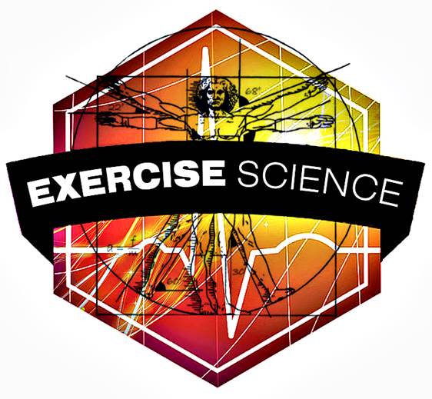
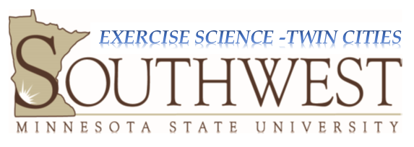

B.S. in Exercise Science: Exercise Specialist Concentration (P)
North Hennepin CC Exercise Science Courses
- BIOL 1001/1101(BIO 200) Biology I w/Lab (MnTC Goal 3) 4 cr.
- CHEM 1010/1061(CHEM 110) Intro. to Chemistry w/Lab (MnTC Goal 3) 4 cr.
- BIOL 2111 (BIOL 305) Human Anatomy & Physiology I w/Lab 4 cr.
- BIOL 2112 (BIOL 306) Human Anatomy & Physiology II w/Lab 4 cr.
- PSYC 1150 (PSYC 101) General Psychology (MnTC Goals 5 & 7) 3 cr.
- MATH 1130 (MATH 200) Elementary Statistics (MnTC Goal 4) 3 cr.
- HLTH 1070 (EXSC 225) Nutrition 3 cr.
- EXSC 1500/2010(EXSC 101) Foundations of Exercise Science 3 cr.
- EXSC 1250 (EXSC 180) Wellness for Life 3 cr.
- EXSC 2270 (EXSC 325) Essentials of Sport & Exercise Nutrition 3 cr.
- EXSC 2490 (EXSC 100/L)Kinesiology 4 cr.
Subtotal = 38 credits
SMSU Exercise Science Core
- MATH 201 Statistical Software 1 cr.
- ENG 360 Scientific and Technical Writing 3 cr.
- EXSC 300 Biomechanics 3 cr.
- EXSC 350 Exercise Physiology I w/Lab 4 cr.
- EXSC 390 Fitness Assessment 2 cr.
- EXSC 400 Motor Learning & Development 2 cr.
- EXSC 475 Capstone Research 3 cr.
- EXSC 480 Principles of Training & Conditioning 2 cr.
- EXSC 490 Exercise Prescription 2 cr.
- EXSC 499 Professional Practicum 3 cr.
Subtotal = 25 credits
SMSU Concentration: Exercise Specialist
21. EXSC 360 Athletic Enhancement & Exercise Leadership 2 cr.
22. EXSC 380 Community and Corporate Wellness and Health Promotion 3 cr.
23. EXSC 488 Professional Communication 3 cr.
- Selected Electives (Choose 2 courses from the following list 6 cr.
- MGMT 300 Management Principles (3 cr.)
- MKTG 301 Principles of Marketing (3 cr.)
- BLAW 305 Legal Environment & Contracts (3 cr.)
- FIN 330 Financial Management for Small Business (3 cr.)
- EXSC 450 Advanced Exercise Physiology (3cr)
- PSYC 301 Sport and Performance Psychology (3cr)
Subtotal = 14 credits

Total = 77 credits
Career Opportunities in Exercise Science: Exercise Specialist

- Personal Training - Corporate Wellness Director - Graduate School in Exercise Science
- Exercise Specialist - Business Owner in Exercise - Professional School
- Athletic Enhancement - Assisted Living (PT, OT, PA, Chiropractic School)
- Manage a Fitness Facility - Sales, Exercise Equipment/Apparel - Athletic Coaching/Strength & Cond.
Updated Spring 2021
The information provided is for advising only. For official curriculum, students should consult the most current SMSU Academic Catalog or their DARS report

